

Project Booklet

Table of Contents

Chapter 1: Abstract 3

Chapter 2: What is a Thermal Camera 4

Human Skin Temperature 5

Advantages and Disadvantages of a Thermal Camera 6

Experiments 8

"The Cups" Experiment 8

Night 8

A Hot Day 8

An Especially Cold Day 8

Image Processing Methods 9

Reference to Past Projects 9

Troubleshooting 10

Difficulties Extracting Raw Data 10

The Algorithm 11

Concept 11

Implementation (MATLAB, Java) 11

The App 12

Many Thanks 13

Resources 14

Table of Figures

Figure 1 - Skin Temperatures 6

# Chapter 1: Abstract

This paper reviews the making of the **ThermTrack** Android App. **ThermTrack** was created in a vision that one day, it will be integrated into a "Smart City" project, in which the goal is to create a better, safer, more effective environment and transportation for pedestrians as well as drivers in the hectic city.

As part of that, our goal was to create an application that can track pedestrians, and be able to keep and display statistical data about the quantity of crossway passers at a given time.

For that we had to develop skills in researching, Image Processing, Java, and Matlab.

Additionally ……….

To summarize, …………..

# Chapter 2: What is a Thermal Camera

In order to understand how a thermal camera works and what we should expect, we looked a little deeper into thermal radiation.

We have learned that thermal radiation includes infrared and visible light, and it is a fundamental mechanism of heat transfer.

Thermal radiation is in fact electromagnetic radiation. It is created when thermal motion of charged particles occurs in matter.[1]

We looked into the way a thermal camera works[2], and here’s a brief, concise explanation:

A **thermographic camera** (also called an **infrared camera** or **thermal imaging camera**) is a device that forms an image using [infrared radiation](https://en.wikipedia.org/wiki/Infrared_radiation), similar to a common [camera](https://en.wikipedia.org/wiki/Camera) that forms an image using [visible](https://en.wikipedia.org/wiki/Optical_spectrum) [light](https://en.wikipedia.org/wiki/Light). Instead of the 400–700 [nanometre](https://en.wikipedia.org/wiki/Nanometre) range of the visible light camera, infrared cameras operate in [wavelengths](https://en.wikipedia.org/wiki/Wavelength) as long as 14,000 nm (14 µm). Their use is called [thermography](https://en.wikipedia.org/wiki/Thermography).

**Wikipedia**, https://en.wikipedia.org/wiki/Thermographic_camera

According to what we learned, **all objects with a temperature above absolute zero emit thermal radiation**, and this is the concept we’ve used in our project.

In our project we were given a mission to track pedestrians on crossways through image processing. We took advantage of the fact that humans (and little animals…) emit radiation in a certain range that is known, due to a known range of the body temperatures.

During our initial experiments, we established that skin temperature range is the relevant range for telling humans from other moving objects, and did a little research, shown in the following page.

## Human Skin Temperature

Human skin temperature varies between about 25 and 36 degrees Celsius. Our body core is, as expected, hotter, and the normal temperature of our inner organs stands at 37°C. [3]

Figure - Skin Temperatures

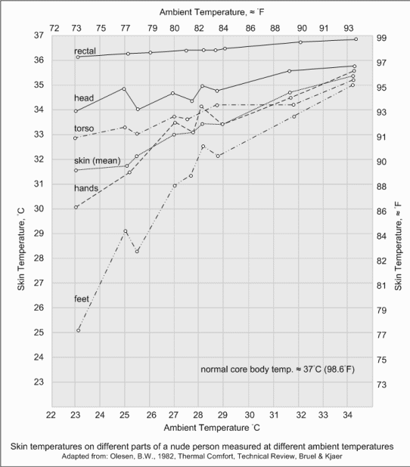

## Advantages and Disadvantages of a Thermal Camera

Like every other tool, thermography has its advantages and disadvantages:

**Advantages**

1. Since its mechanism is based on temperature, it is relevant to our project, since it is human and animal oriented.
2. Performs better than a regular camera during the night, including when it’s **completely** dark.

**Disadvantages**

1. During really hot days, when the environment (roads, ground, etc.) is hot as well, a regular camera will outperform the thermal one. For example - during a hot day, there may not be a noticeable difference between the temperature of the ground and the temperature of a human walking on it.
2. Takes time to calibrate, whereas a regular camera doesn’t require calibration at all.

# Chapter 3: Experiments

Dfdfd

## "The Cups" Experiment

Dfdfd

## Night

Dfdf

## A Hot Day

Dfdf

## An Especially Cold Day

gghgh

# Chapter 4: Image Processing Methods

For each one, add advantage and disadvantage

## Reference to Past Projects

# Chapter 5: Troubleshooting

## Difficulties Extracting Raw Data

# Chapter 6: The Algorithm

## Concept

## Implementation (MATLAB, Java)

What libraries we used, etc

# Chapter 7: The App

Hfghfgh

# Chapter 8: Summary

# Chapter 9: Resources

1. **Wikipedia, Thermal Radiation**. *https://en.wikipedia.org/wiki/Thermal_radiation*
2. **Wikipedia, Thermographic Camera**. *https://en.wikipedia.org/wiki/Thermographic_camera*
3. **Healthy Eating**. *http://www.healthyheating.com/Definitions/facts_about_skin.htm#.WAY6Puh96Ul*